An online event management and matchmaking system for board game clubs
Contents
Planning and Preparation 3
Background and problem 3
The goal 3
The proposed solution 3
Components 4
Risks and Schedule 4
Method 5
Infrastructure 5
Project Work Completed 7
Literature 7
Initial Prototype 7
• Authentication 8
• Front-end 8
• Request logging 9
• Event API 10
• Game Search API 11
Legal, social, ethical and professional issues 14
Reflection 15
References 17
Appendix A 18
Appendix B 19
Appendix C 20
Appendix D 21
Appendix E 22
Appendix F 23
Appendix G 25
Appendix H 26

Planning and Preparation

Background and problem
I am an avid board gamer and am a part of a local group that meet weekly in a pub for games, plus other ad hoc meet ups. The weekly evenings starts at 7.30 when there is a roll call of members saying which games they have brought. Once all the games are mentioned, people suggest games to play and form and join groups.
It's only a community group but we can easily get 50-60 people every week, essentially taking over the pub. This means that the roll call is chaotic with people not hearing games mentioned or not knowing what they are, as portrayed by the images in Appendix A. Some people started to use Facebook to pre-arrange games with some using the polling feature. The polling feature has its issues (such as difficult use on mobile devices) and other non-Facebook users feel left out. There is also a problem of new people finding the whole roll call intimidating and some people end up without a group.

The goal
The goal of this project is to create a method of creating groups and matchmaking players at the start of the night to avoid the chaos of the roll call and to improve the overall experience of the night, making it more inclusive and friendly. It should allow games to begin sooner, extending the time available in the night for members to enjoy themselves. It would support the organisation of pre-arranged and recurring games, as well as games set up on the night.

The proposed solution
My intention is to create a website to allow members to list games that they have available on a particular night and to register interest in playing certain games on that night. Users will sign up and log in to the system in order to register a name and keep a record of their games and events. The user will join one or more particular groups in their area. There will be a page of upcoming events that are in the user’s groups, which the user can view. The system will then show a list of games which other users have proposed to play and allow the user to add some of their own or join other games.
The system would display information about the games, such as a description and the number of players, etc. This would allow members to pre-arrange games and learn more about those games before playing. Later, there would also be the option of more advanced matchmaking methods such as game and player preferences, random games, or skill-based matching. On the night, members would see the list of available games on a big screen in the venue and could register interest in them at that point or add their own games, using their own device or by speaking to another member with access to the website. The games could be announced and then once interested members have settled on a game (or had the system has been activated to arrange it), they join their table and start the game. Remaining members will easily be able to see what other games are still available to play and with who.
The system would also integrate with the group’s website and social media, sharing details of proposed and arranged games. This would allow new and non-members to be more informed at the start of the night, as well as promoting the events to the public. At a meeting with the user group, this proposal was confirmed by the group leader, as seen in Appendix B.
Utilising my personal and professional knowledge of web development with HTML and JavaScript and expanding upon my level 3 Open University studies in Developing concurrent distributed systems (M362), Ebusiness technologies: foundations and practice (T320) and Fundamentals of interaction design (M364), I intend to develop a multi-tiered, distributed web application which is accessible on a range of devices and by a range of users.

Components
The system can be broken down into four main components:
- User Management – account settings and game preferences
- Event Management – recurring and ad hoc events, e.g. “Tuesday evenings”
- Game/Library Management – collections of owned and available games in the group
- Match Management – the actual games being arranged & played

Risks and Schedule
An updated risk table is available in Appendix C. In particular, I have recently had trouble keeping up with the schedule of work. This highlighted the real impact (High) and likelihood (High) of risk R9 due to requirements of other OU study and an increased workload at work from starting a new job. I have also included a new risk R15, because of the unexpected time involved in non-work related activities such as the needs of family and friends, as well as illness over the Easter period. The initial schedule was far too optimistic and rigid, when it should be flexible. These problems have caused several items on my schedule to be delayed or rearranged.
For planning and management, I am using Project in a Box Planner software, which includes a Gantt chart visualisation of the schedule and also Risk and Issue logs. This is because the package is free and includes brief project management guides for various types of project, from simple to complex. The package is also easy to use but still much more usable and powerful than other free project management tools and templates, such as GanttProject.
I have not, yet, completed the Risk and Issue logs within the software, as I have been waiting to complete the first prototype before liaising more with the client and formalising the risks, requirements and actions.
Below, is an updated Gantt chart of the schedule and a breakdown can be found in Appendix D.
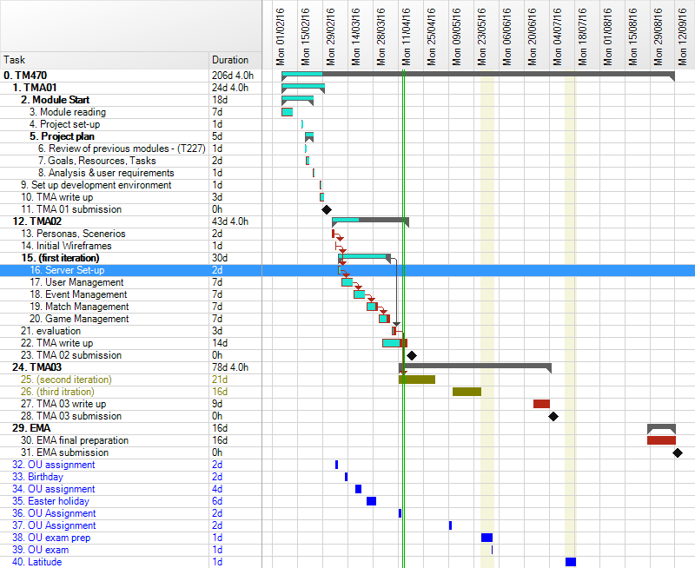
Figure 1 - Gantt Schedule

Method
I have also not, yet, utilised any aspects of the Agile development methodology, due to my initial prototype (and first iteration) taking much longer than initially planned. Now that the prototype is completed, I will be able to meet with the user group to discuss further requirements and prepare User Stories and Personas, in order to focus development in line with the requirements.
I still think that an iterative model is suitable for this project, where all elements of the project are included from the start but are refined throughout the process.

Infrastructure
In order to make the final application as user-friendly and efficient as possible, I have decided to adopt a Model-View-Controller architecture, where the Model is a representation of the data that a user sees and interacts with, the View is how the user sees and interacts with that data and is updated by the Model, and the Controller is the business logic which manipulates the data, i.e. the Model.
The idea is to separate presentation logic from business logic and presentation state, so that the logic and the presentation can be altered independently without affecting the other. This has the benefit of efficient design in terms of development – the entire codebase does not need to change to change either the logic or the presentation.
I have decided to use the AngularJS framework for this purpose because of its simple HTML-expanding design rather than complicated templating engines, which means I do not need to learn even more new languages. Angular actually expands on the capabilities of the Controller and View to enable better user interactions and usable code. This has resulted in it being referred to as MVW, “Model-View-Whatever works for you” (Minar, 2012) because it enables a diverse range of methods to interact with the Model and View, not restricted to Controller types. Angular provides sophisticated but simple data binding between the View and the Model that allows much processing to be handled by the client, freeing resources on the server.
To expand the View component, I have decided to also use JQuery, which is a JavaScript library designed to simplify client-side manipulation of HTML. It is strongly supported by Angular and is widely used on the internet.
Also, to speed development of prototypes, I am using the Bootstrap library, which includes HTML, CSS and JavaScript templates to create consistent and mobile-friendly websites very quickly, which is important, as a particular use case will be the use of the system on mobile devices at events.
As the Model component, I have decided to use a Node.js server to host the application and act as the service layer of the Model to interact with the database layer. Using Node allows me to finely control access to the data and provide secure business logic. Node is developed in JavaScript, which also means that I am using existing skills rather than learning new languages. Node also has an extensive catalogue of packages which can be easily installed and automatically updated.
For persistence, I have decided to use an online database service, Orchestrate.io, in order to explore the benefits and pitfalls of wider distributed web services. Using a database as a service also means that I do not have to be concerned with the maintenance or scaling of resources, as these are managed by others. The database is considered to be a JSON NoSQL store, which means that data is stored in JavaScript object documents rather than relational tables with rows. This is in order to improve the ease of accessing the data and to reduce the complexity of the database. Again, using a JavaScript-based database means that all the development is in a single main language and all systems are naturally compatible. This is not a free service but, as a student, I have an account with 10 million API requests per month. Significantly more than I expect to need, currently.
On top of the Node server, I have decided to use the Express.js web server framework, which allows simple servers to be set up extremely quickly and easily. It handles the routing of HTTP requests, errors and cookies & sessions. Using Express in this set-up means that there is a wide range of established practices and tutorials, which will speed up development.
I would also be using another external data source, BoardGameGeek.com, which has many details about almost every published board game in existence and provides an API to access that data.
The Controller component is mainly handled by Angular so that much of the business logic is provided by the client. The server (part of the Model) also handles some business logic, in order to provide security around the data, which is provided via a RESTful API. This means that the client and the server are separated and that it is possible for different clients (perhaps developed by others) to utilise the same server API to access the same data but use that data in different ways. A separation of data and how that data is used.
In my application, the API will be accessed via AJAX calls directly to the API, which means that data can be retrieved and manipulated in the background without affect the user’s interaction with the application. Emphasising a client-based application with AJAX also means that less data has to be sent and received between server and client because the presentation information is handled separately and only the required Model data is transferred. This improves the responsiveness of an application, which will be critical to the success of my project.

Project Work Completed

Literature
In addition to the previous books, I have been using JavaScript Patterns by Stoyan Stefanov (2010) as a very good reference, particularly for working with JSON and asynchronous events. Stefanov is an engineer at Yahoo!, one of the world’s largest services. The text is accessible and obviously written by somebody passionate about clarity and understanding. As the entire application architecture is JavaScript-based, it is important that I learn best practices for the more intricate aspects of the applications, such as the API development and AJAX communication.
To develop my knowledge of asynchronous JavaScript, I found two specific articles extremely informative: By example: Continuation-passing style in JavaScript by Matt Might (Might, 2010) and How do Promises Work? (Quil, 2015). These articles really explained how JavaScript, as a generally single-threaded language, can deal with concurrent applications and have proven very useful for understanding the wider workings of AJAX requests.

Initial Prototype
- Set-up
Work on the initial prototype was very slow as I was really trying to develop a reduced first iteration of the product than an actual prototype. This work began with setting up the server software and starting to develop the API.
Setting up the web server, itself, was extremely easy using the Express framework generator (Expressjs, 2016) and it allows relatively easy development of APIs with its simple routing middleware. I set up the server to deliver static files, such as HTML, JavaScript and images located in the /public/ folder from the root URL, e.g. www.example.com/index.html when the file is stored at /public/index.html. I then routed calls to /api/ to the specific controller to handle API requests. The client-server nature of the application means that the static files could be on a different server, which is a good way of improving performance because the load is shared and means there are more resources available for business logic. However, for the sake of development, I have included them on the same server. The /api/ prefix makes it obvious if a request is for the API or for a static file/client-side route.
To begin my testing and learning of the architecture, I installed the BoardGameGeek API Node package, bgg, and created a simple API endpoint, /api/bgg/user/:username, to retrieve user information. This example uses the basic example included with the package (Montes, 2016):
router.get('/bgg/user/:username', function(req, res, next) {
var options = {
timeout: 5000,
retry: {
initial: 100,
multiplier: 2,
max: 15e3
}
}
var bgg = require('bgg')(options);
bgg('users', {name: req.params.username})
.then(function(results){
res.send("Name: " + results.user.firstname.value + " " + results.user.lastname.value);
console.log(results);
});
});
Table 1 – BGG username check API endpoint
The res.send() method is a part of the Express framework and sends an HTTP response with the appropriate headers and content. In basic usage, a String is sent and a response code of 200 (OK) is assumed. Without a client application to receive this response, the browser displays the content, depending on the browser.
This worked well straight away and I felt very positive about the decision to implement an API. This has since been expanded.
- Authentication
Following this, I installed the Passport.js authentication middleware for Express, as it was specifically compatible with Express middleware and allowed the possibility of allowing users to log in with a range of existing credentials such as various social media accounts. Passport works by including different “strategies” for each type of credential or authentication task, which developers should be able to just plug in to their application. It uses other middleware to store and manage the cookies and sessions but it handles the authentication and sending of the cookies with each HTTP request. It appeared that it would be easy to set up but actually highlighted my lack of experience with Node and Express development.
For several days, as highlighted in the git commit logs in Appendix E, I worked on setting up authentication and authorisation using a tutorial by the company behind the Orchestrate database service (Voorhis, 2014). At first, I tested the login component using basic html forms and a user hard-coded into the database. It took some time to understand the methods for the database API and the Passport middleware and, in particular, adapting the tutorial code to work as an API rather than with server-generated pages. A main issue I encountered when starting to think about the user sign-up process was that the Passport documentation was very light, assuming a developer’s greater knowledge of Express middleware. It took a significant amount of searching through the packages source code to work out how to create a new “strategy” for user sign-up.
- Front-end
Once the authentication was mainly working, I decided to start work on the client front-end, so that I had something more tangible to work on, as well as more accurately test the API. Also, as user experience is so critical to the success of the project, it was important to get it working well as soon as possible. Along with Angular and Bootstrap, I have also used a plugin called Notie.js to improve user feedback. The plugin produces simple, temporary notifications for the user, currently set up as a small bar across the top of the screen with different colours for positive and negative notifications:
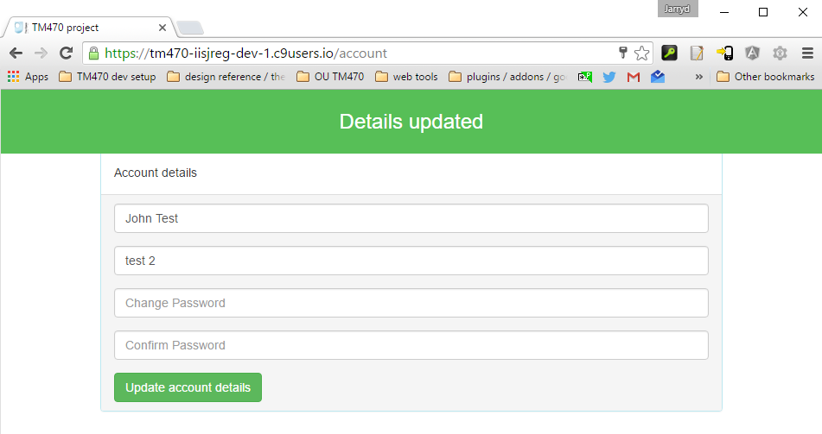
Figure 2 - Notie.js success notification
- Request logging
As I was doing more development and testing, it became increasingly difficult to see what the server was doing at a particular time. The Express generated installation, by default, included a logger called Morgan, which intercepts HTTP requests and displays the results of that request in the console. However, this is only displayed after the request in completed, so I included some further logging output at the start of each request:
function pad(str, max) {
str = str.toString();
return str.length < max ? pad("0" + str, max) : str;
}

logger.token('id', function getId(req) {
//new Morgan token needed to show request ID
return req.id;
});

logger.token('fixclfdate', function getclfDate(req) {
//new Morgan token needed to remove the extra "+" from the clf date; also add || characters
var date = new Date();
return date.toCLFString() + " ||";
});

//set up Morgan output with new tokens
app.use(logger(':id :fixclfdate :method :url :status :response-time ms - :res[content-length]'));

var requests = 0;

app.use(function(req, res, next) {
//increment request counter and assign it to the request
requests++;
req.id = pad(requests,5); //make the ID always 5 characters long
next();
});

app.use(function(req, res, next) {
//log all requests at start of request, because Morgan only logs request at end.
var date = new Date();
console.log(req.id + " " + date.toCLFString() + " >> " + req.method + " " + req.path);
next();
});
Table 2 – Extra logging in api.js
In these additional functions, I have assigned an ID to each request (a simple counter) and displayed the HTTP request information at the start of the transaction, as well as adding the ID to the Morgan logger output at the end of the transaction. I also had to modify the default Morgan date format, as it included a “+” sign at the end which was not in the custom log, making it difficult to read. The image below shows the output with >> marking the start and || marking the end of the requests.
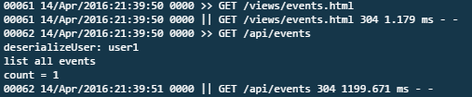
Figure 3 - Additional logging output
This addition allowed me to quickly see which parts of the code were getting stuck or taking too long. However, this method does not extend to all console output, which makes it difficult to see which process logs are associated with which request. There are other, fuller featured logging middlewares that I will be investigating.
- Event API
The main bulk of work has been adding the functionality to create events and to add matches (individual instances of a game) to an event. After routing to the particular page, the data is retrieved via AJAX calls from the Angular client controller to the node API endpoint. For example, the events page uses the events controller and uses the Angular $http service to send an XMLHttpRequest (XHR) request to the API URL:
//Load event list
function getEvents(){
$http.get("/api/events")
.then(function(response) {
console.log(response.status);
$scope.eventlist = response.data.results;
}, function(error){ //understands 4XX and 5XX HTTP error statuses
console.log(error.data);
$location.path("/login");
//show login
});
}
getEvents();
Table 3 – list of events controller AJAX request
routerAPI.get('/events/', //get all events
function(req, res){
if(!req.user){
console.error("not logged in");
res.status(403).send("not logged in");
}
else{
console.log("list all events");
db.list('Events') //will eventually change to accommodate multiple organisations
.then(function (result) {
console.log("count = " + result.body.count);
if(result.body.count == 0){
console.log("no events found");
res.status(200).send("no events found");
}
res.send(result.body);
})
.fail(function (err) {
console.log("error : count=" + err.body.count);
res.send(err);
});
}
});
Table 4 – list of events API endpoint
This $http.get() method is asynchronous and creates a “promise” in order to handle the eventual response. This means that an empty object is created and is then “fulfilled” when the real value is returned in the HTTP response. The .then() method then accepts the fulfilled promise and handles the actual data.
The API uses collections and elements along with the standard HTTP verbs to create a resource-based, and RESTful, service that means it is semantically clear how to interact with it, i.e. the current endpoints or Uniform Resource Identifiers (URI) in use are:
URI | Type | HTTP methods accepted
/events/ | Collection | GET for retrieving the list of events  POST for submitting a new event
/events/:event | Element | GET for retrieving a specific event
/events/:event/matches/ | Collection | GET for retrieving the list of matches  POST for submitting a new match
/events/:event/matches/:match | Element | GET for retrieving a specific event
/events/:event/matches/:match/players | Collection | GET for retrieving the list of players  POST for submitting a new player
Table 5 – list of URIs (: refers to a parameter)
- Game Search API
An important feature of the system is for users to be able to add games to the system to list for playing. In order to make this as quick as possible and to maintain consistent data, once a user inputs a game name, the system searches the BoardGameGeek database, via the API, for matching games and presents suggestions to the user. The user can then select the appropriate game and the system then gets further details about that game including an image and description. The user can then confirm that the correct game was retrieved and add that game to the event. The interface reacts to the user’s input and handles the request in the background with visual feedback, so that the application seems faster, by using an icon next to the search box which indicates that the application is searching and then found the game and also an alert box that describes the background action. Appendix F shows images for the above sequence of steps. The interface feedback is controlled by the Angular Controller and View. In particular, Angular include directives to make elements of the page conditionally visible with ng-show, ng-if and ng-hide HTML attributes. Currently, there is a mess of shows and hides, which needs to be rationalised and clarified to avoid problems and complexity.
The table below shows the different elements of the page which are shown and hidden based on the conditions of various variables that are updated by the Controller.
<div class="row">
<div class="col-lg-12">
<div class="input-group">
<input type="text" name="name" placeholder="Game (search BoardGameGeek)" ng-model="match.game" class="form-control" ng-blur="checkGame()">
<span class="input-group-addon" ng-click="checkGame()">
<i ng-hide="checkingGame || match.id || notFound" class="glyphicon glyphicon-search" style="cursor: pointer;"></i>
<i ng-if="checkingGame" class="glyphicon glyphicon-hourglass"></i>
<i ng-if="match.id" ng-hide="checkingGame" class="glyphicon glyphicon-ok"></i>
<i ng-if="notFound" ng-hide="checkingGame" class="glyphicon glyphicon-remove"></i></span>
</div>
<input type="hidden" name="BGGid" ng-model="match.id">
</div>
</div><br />
<div class="row" ng-show="BGGresults && BGGresults.length > 0" ng-hide="notFound || checkingGame">
<div class="col-lg-12">
<ul class="list-group">
<li class="list-group-item">
Suggestions:
</li>
<li class="list-group-item" style="cursor: pointer;" ng-repeat="res in BGGresults" ng-click="select(res.id,res.name.value,res.type)">
<b>{{res.name.value}}</b> ({{res.yearpublished.value}}) <small><i ng-if="res.type != 'boardgame'">({{res.type}})</i></small>
</li>
</ul>
</div>
</div>
<div class="row" ng-show="gettingGameDetail || checkingGame || notFound">
<div class="col-md-12">
<div class="alert alert-info" ng-show="gettingGameDetail">
Getting game details!
</div>
<div class="alert alert-info" ng-show="checkingGame">
Searching for game...
</div>
<div class="alert alert-warning" ng-show="notFound" ng-hide="checkingGame || gettingGameDetail">
Game not found. You can enter a description and number of players, below.
</div>
</div><br />
</div>
<div class="row" ng-show="notFound"> <!-- GAME NOT FOUND ALLOW MANUAL ENTRY -->
<div class="col-md-10">
<input type="text" name="description" placeholder="Description" ng-model="match.description" class="form-control">
</div>
<div class="col-md-2">
<input type="text" name="numPlayers" placeholder="# Players" ng-model="match.numPlayers" class="form-control">
</div>
</div>
<div class="row" ng-if="showGameDetail">
<div class="col-md-2">
<img ng-src="{{gameDetail.thumbnail}}">
</div>
<div class="col-md-10">
<h4 class="media-heading"><span><b>{{gameDetail.name.value}}</b> ({{gameDetail.yearpublished.value}})</span></h4>
<small><i class="glyphicon glyphicon-user"></i> {{gameDetail.minplayers.value}}-{{gameDetail.maxplayers.value}} </small>
<span class="label label-info" ng-repeat="link in gameDetail.link"><i ng-if="link.type == 'boardgamecategory'">{{link.value}}</i></span>
<p ng-bind-html="gameDetail.description"></p>
<p><small><i><a ng-href="http://boardgamegeek.com/{{match.type}}/{{match.id}}" target="_NEW">View this game on BoardGameGeek</a></i></small></p>
</div>
</div>
Table 6 – Game search box showing conditional elements
- Game description encoding
One issue I came across when retrieving the game data from the BoardGameGeek API was that the long game description text had unexpected HTML Unicode characters, &amp;&amp;#35;#10;&amp;&amp;#35;10;. Looking at the original website, there should have been a new paragraph after the word “hand”, as seen in Appendix G.
I modified the client-side code to sanitise the text for encoded characters and to display them as HTML, using the Angular ng-bind-html directive, but it still resulted in Unicode characters. It seemed that something was doing extra encoding of characters as #35; is the Unicode for the # symbol. In the original database, this must have been represented by two “newline” characters: &#10; which got translated to HTML paragraph tags.
After looking into the bgg node package, I found that the plugin was set to sanitise the response from the API by default but, as the text already used Unicode characters, it did not need to be sanitised, so I turned it off. This, along with the client-side displaying Unicode characters as HTML meant that the final output was satisfactory but not perfect. The generated HTML did include the newline characters, but the next step will be to convert them to HTML paragraph tags on the client. More testing is also required for other possible Unicode characters.

Legal, social, ethical and professional issues
As a non-critical, community project, there are fewer legal, social, ethical and professional concerns that there might be on other projects but they are still important considerations. In particular, the system would be collecting data from its users.
Primarily, the system allows a user to create an account and collects a unique username for that account. It also allows users to provide additional, optional, information such as a name and their interests. The reason for creating an account is so that users can record their available games, like a library, and store settings for the eventual matchmaking aspect of the system. As a community app, it also allows members to identify themselves in the group. However, as a key intention for the system is to improve the experience of new attendees and non-members, the system will allow users to be included in events as “guests” where they would have the option of providing a name or remain anonymous and no further information would be stored. Another consideration of data, is that the core idea of the system is to sign up to particular events in a physical place. This means that the location of a person at a particular time may be recorded. The username and other details of members do not need to be factual details and could be personas but, as these details are linked to an identifiable individual, they are considered personal data.
Therefore it is important to keep any data that is recorded secure. Currently, the system’s data is stored in plain text (in JSON format) in an online database provided as a service by a third party organisation hosted in a cloud data centre in the UK, so it affected by UK law on data protection and liability. This data can be accessed by myself as administrator of the data, by the host organisation “(i) to comply with the law, regulatory requirements, or legal or regulatory process; (ii) to enforce this Agreement; or (iii) to respond to claims that you are using the Service to perform or support activities that violate the law or the rights of third parties or this Agreement” (CenturyLink, 2015) and by users of the system via the API. The server communicates requests to the database API with a specific API key which is stored on the server. Users can view the identifiable information of other users which those users have made available in the system. Users can only modify personal data with the user of their password.
Passwords are currently stored in the database using encryption according to industry best practice. Provided passwords are hashed using the Node crypto package’s pbkdf2 method using a random 512 bit salt and the sha512 algorithm to derive a 512 bit key from 25000 iterations. If an attacker gained access to the hashed passwords from the database, the salt ensures that attackers can't use specialized attacks like lookup tables and rainbow tables to crack the collection of password hashes quickly, though it doesn't prevent them from running dictionary or brute-force attacks on each hash individually. The iterative pbkdf2 function “stretches the key”, making the hashing function very slow and increases the amount of work needed to crack the hash so much that it is almost impossible or, at least, extremely resource-intensive.
Although the other data is currently stored in plain JSON format, it would be possible to also encrypt some other personal data but would lose significant functionality from the database. In this project, this level of security is not needed.
I have not, yet, completed any in depth research or developed a plan for future research but, as the initial prototype is now finished, I will eventually begin conducting short interviews and observations of users in order to understand and improve the user experience. I will therefor need to closely consider the environment and questions that will be asked.

Reflection
In the last 6 weeks, I have begun a new job role as a web developer which has been an amazing opportunity but also a significant increase in workload. I am also fortunate that in this role, I am utilising many of the same tools and languages that I am using for this project, which means that I am improving my skillset a lot quicker but it has meant that I am doing much the same type of work during that day and during the evenings and weekends. This has resulted, at several points, in getting particularly tired and unable to concentrate.
This was exacerbated when there I had two other Open University assignments to complete for the 9th and 23rd March and had not been able to keep up with the module reading. I had to take some time away from this project to rest and to complete the other assignments. This is evident in my commit logs (Appendix E) and project log (Appendix H) where there is a gap between the 8th and 30th March. I am pleased that I achieved very good marks for those assignments but it meant that when returning to this project, it took significant effort to get back into the rhythm of development.
Part of the problem was that I got stuck when implementing the user authentication functionality. I wanted to do this first because it is such a core aspect of having users. However, it was a real struggle and test of my ability. It is still not implemented quite correctly but I had to move onto other features.
I think the issues that I encountered were because of my possible over-reliance on plugins and middleware software. In the hope of fast development, I actually spent possibly more time implementing a plugin rather than spending time working with the tools that I had. I might still change or remove the plugin used. In hind sight, I should have considered the implications of the tool more before starting work.
This delay has pushed much of my original schedule back. I was disappointed that I was not working more iteratively but realised that iterative development does not have to be fast – I was only using certain aspects of the Agile methodology – and now that I have a good basic prototype, I am more confident that I will be able to work more iteratively once I have discussed the next requirements with the user group.
Reflection after Action:
- What went well? What can I learn from that for the rest of my work on this module?
I think the API work has gone very well once I moved away from just working on the API to working on both the front- and back-end at the same time. This made development more interesting and responsive, which reduced my tiredness overall.
- What didn’t go so well? How did I recover from my problems? What can I learn from that for the rest of my work on this module?
Writing this TMA has been very tough. I have found that lower prescriptiveness of the assignment a challenge to know what to write about and to what depth.
- Have I reached an acceptable standard, both according to what the module team and my tutor have told me and according to my own judgement?
I am not happy with the quality of this assignment. I have been so focussed on development that I have found it a struggle to get into a report writing mind-set. I feel that I should be going into more detail about some of the concepts discussed but don’t have enough time.
- Have I met the learning outcomes for this piece of work?
I believe I have sufficiently analysed my problem and documented my progress in developing a solution. I have revised my risks and plan and identified further information sources to expand my level 3 understanding. I have reflected on my working practice. I have considered some legal, social, ethical and professional considerations but only briefly.
Therefore, I think that I have most met the learning outcomes but with much room for improvement.
- If not, what am I going to change?
I need to maintain a balance between TMA writing and development, rather than developing first. My most prevalent challenge in report writing is knowing where to start but once I have put down the first words, the rest becomes easier. I should remember this and write as I go, so that it is not so daunting later.

Words: 4968

References

CenturyLink, (2015). Orchestrate Terms of Service. [online] Orchestrate. Available at: https://orchestrate.io/legal/tos [Accessed 17 Apr. 2016].
Expressjs. (2016). Express application generator. [online] Available at: http://expressjs.com/en/starter/generator.html [Accessed 14 Apr. 2016].
Might, M. (2010). By example: Continuation-passing style in JavaScript. [online] Matt.might.net. Available at: http://matt.might.net/articles/by-example-continuation-passing-style/ [Accessed 14 Apr. 2016].
Minar, I. (2012). MVC vs MVVM vs MVP. [Blog] Available at: https://plus.google.com/+IgorMinar/posts/DRUAkZmXjNV [Accessed 13 Apr. 2016].
Montes, L. (2016). bgg. [online] npm. Available at: https://www.npmjs.com/package/bgg [Accessed 13 Apr. 2016].
Quil, (2015). How do Promises Work? - Quils in Space. [online] Robotlolita.me. Available at: http://robotlolita.me/2015/11/15/how-do-promises-work.html [Accessed 14 Apr. 2016].
Stefanov, S. (2010). JavaScript patterns. Sebastopol, CA: O'Reilly.
Voorhis, J. (2014). Build User Authentication with Node.js, Express, Passport, and Orchestrate - CenturyLink Cloud Developer Center. [online] CenturyLink. Available at: https://www.ctl.io/developers/blog/post/build-user-authentication-with-node-js-express-passport-and-orchestrate [Accessed 14 Apr. 2016].

Appendix A
Images of venue at roll call.
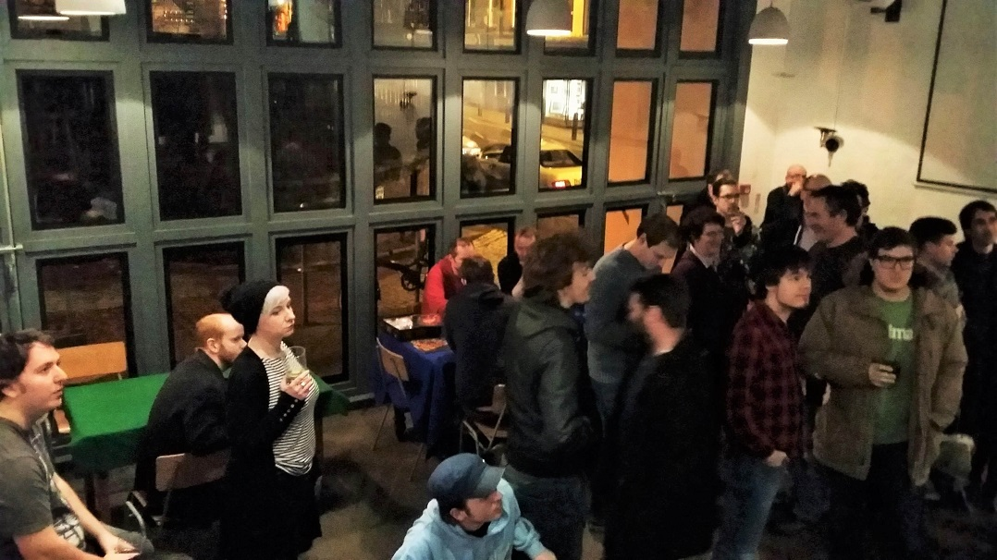



Appendix B
Verbatim comments from discussions with a few core members of the user group.
John, Group Leader:
“Jarryd is making the app as part of his Uni work - and the scope is somewhat up to him, however...
The app needs to address several problems. And when you get into it, there's a lot of user requirements, issues and yada for our group. There's a balancing act of allowing people to organise tricky to get to table games with known players and also being welcoming to new people and not just having a cliquey Youre Not From Around Here cold shoulder thing going on, AND addressing social anxiety issues, and unfamiliarity, and yada yada yada. ( Headache ).
But basically game organising that is -
1) Inclusive of *everyone*. Particularly new people and those who want least fuss.
2) Allow good organisation of pre-arranged games.
3) Allow good organisation of games on game night.
Also the point of all this is to let the system / computer do the management. If someone is having to babysit a process it's a failure.
All you really need is a central list of available games, and people can vote on what they want to play. The particulars of that list break down into pre-arranged games, so games that go up on a list before game night. And then games that turn up adhoc on game night and are visible to everyone - either via their mobile device, OR, and here's the kicker, available through a large public display.
Ideally what you want is an app that allows a given user to keep a record of whatever games they have. Flag them to be pre-arranged or not. Or flag them as games I am bringing with me this week. Voting to play a game is as simple as clicking on a game in the list, which will mark you as voted, and on game night when the process is resolved, the system will tell you what you're playing based on a bunch of voting weights.
On game night the whole thing should be available from a large public display ( via hooking any device up to a chromecast ) - which allows new people to see whats available to play as well as those who dont buy into the app process to still interact with whats going on.
Effectively you move game organising into an on screen digital space. To the refuseniks or new it will be better than a roll call - no having to shout what you have or failing to hear what others have. To those who do buy into it they will get a way to browse whats available AND - cool thing - be able to read what a game actually is if they dont know ( which is most of the time ) via a click.
As for being available for other gaming groups, yeah, sure, very possible in theory. Development is somewhat Jarryds thing atm as he's doing it to fulfill course requirements. So. It may or may not be a workable prototype. Plus theres an issue of user buy in - if no one is interested its not going to work out, but, casting it onto a big screen guarantees its at least somewhat fit for purpose as it will replace a game roll call.”
Pete
“The interface and experience is key to user buy-in and acceptance – nothing should be complicated or time-consuming. The app should be able to take a user’s secret preferences of other players to play with or avoid. “

Appendix C
Updated table of risks with High impact and High or Medium likelihood risks in bold and updates highlighted in grey.
# | Risk | Importance / Impact | Likelihood
R1 | Client does not accept the final product | H | L
R2 | Client accepts product but there is little or no use of product | H | M
R3 | Product does not work as intended | H | M
R4 | Infrastructure fails (such as host or database) | H | L
R5 | Cost of infrastructure is prohibitive | M | L
R6 | Project scope becomes unmanageable | M | M
R7 | Chosen frameworks become unavailable | M | L
R8 | Chosen frameworks are more difficult to learn than expected | H | M
R9 | Other unexpected OU study or work impacts availability | H | H
R10 | Conflict between users over project requirements | H | H
R11 | Lack of cooperation from users | M | L
R12 | Unclear or incorrect requirements | M | M
R13 | Lack of access to game information from external resource | M | L
R14 | Unable to use projector in venue | L | L
R15 | Other unexpected time requirements, such as illness, holidays, or family & friend needs. | H | H

Appendix D
Work Breakdown Schedule of tasks, including % complete
ID | WBS Code | Name | Start | Finish | Duration | % Complete
0 |  | TM470 | 06/02/2016 | 12/09/2016 | 206d 4.0h | 10.4
1 | 1 | TMA01 | 06/02/2016 | 01/03/2016 | 24d 4.0h | 100
2 | 1.1 | Module Start | 06/02/2016 | 24/02/2016 | 18d | 100
3 | 1.1.1 | Module reading | 06/02/2016 | 12/02/2016 | 7d | 100
4 | 1.1.2 | Project set-up | 17/02/2016 | 17/02/2016 | 1d | 100
5 | 1.1.3 | Project plan | 19/02/2016 | 24/02/2016 | 5d | 100
6 | 1.1.3.1 | Review of previous modules - (T227) | 19/02/2016 | 19/02/2016 | 1d | 100
7 | 1.1.3.2 | Goals, Resources, Tasks | 19/02/2016 | 21/02/2016 | 2d | 100
8 | 1.1.3.3 | Analysis & user requirements | 23/02/2016 | 24/02/2016 | 1d | 100
9 | 1.2 | Set up development environment | 27/02/2016 | 28/02/2016 | 1d | 100
10 | 1.3 | TMA write up | 27/02/2016 | 29/02/2016 | 3d | 100
11 | 1.4 | TMA 01 submission | 01/03/2016 | 01/03/2016 | 0h | 100
12 | 2 | TMA02 | 05/03/2016 | 17/04/2016 | 43d 4.0h | 35
13 | 2.1 | Personas, Scenerios | 05/03/2016 | 06/03/2016 | 2d | 0
14 | 2.2 | Initial Wireframes | 07/03/2016 | 07/03/2016 | 1d | 0
15 | 2.3 | (first iteration) | 08/03/2016 | 06/04/2016 | 30d | 90
16 | 2.3.1 | Server Set-up | 08/03/2016 | 09/03/2016 | 2d | 100
17 | 2.3.2 | User Management | 10/03/2016 | 16/03/2016 | 7d | 100
18 | 2.3.3 | Event Management | 17/03/2016 | 23/03/2016 | 7d | 100
19 | 2.3.4 | Match Management | 24/03/2016 | 30/03/2016 | 7d | 80
20 | 2.3.5 | Game Management | 31/03/2016 | 06/04/2016 | 7d | 70
21 | 2.4 | evaluation | 07/04/2016 | 09/04/2016 | 3d | 50
22 | 2.5 | TMA write up | 02/04/2016 | 16/04/2016 | 14d | 70
23 | 2.6 | TMA 02 submission | 17/04/2016 | 17/04/2016 | 0h | 0
24 | 3 | TMA03 | 11/04/2016 | 05/07/2016 | 78d 4.0h | 0
25 | 3.1 | (second iteration) | 11/04/2016 | 01/05/2016 | 21d | 0
26 | 3.2 | (third itration) | 11/05/2016 | 27/05/2016 | 16d | 0
27 | 3.3 | TMA 03 write up | 25/06/2016 | 04/07/2016 | 9d | 0
28 | 3.4 | TMA 03 submission | 05/07/2016 | 05/07/2016 | 0h | 0
29 | 4 | EMA | 27/08/2016 | 12/09/2016 | 16d | 0
30 | 4.1 | EMA final preparation | 27/08/2016 | 12/09/2016 | 16d | 0
31 | 4.2 | EMA submission | 12/09/2016 | 12/09/2016 | 0h | 0
32 | 5 | OU assignment | 07/03/2016 | 08/03/2016 | 2d | 0
33 | 6 | Birthday | 12/03/2016 | 13/03/2016 | 2d | 0
34 | 7 | OU assignment | 18/03/2016 | 21/03/2016 | 4d | 0
35 | 8 | Easter holiday | 24/03/2016 | 29/03/2016 | 6d | 0
36 | 9 | OU Assignment | 11/04/2016 | 12/04/2016 | 2d | 0
37 | 10 | OU Assignment | 09/05/2016 | 10/05/2016 | 2d | 0
38 | 11 | OU exam prep | 27/05/2016 | 02/06/2016 | 1d | 0
39 | 12 | OU exam | 02/06/2016 | 02/06/2016 | 1d | 0
40 | 13 | Latitude | 13/07/2016 | 19/07/2016 | 1d | 0

Appendix E
List of Git commits, highlighting initial work on authentication
80e0955 - Wed Apr 13 22:26:56 2016 : work on bgg game searching and match display
4d36155 - Sun Apr 10 19:48:44 2016 : added joining matches
846eb72 - Sun Apr 10 17:44:49 2016 : added match & event deletion for admin users
f5de992 - Fri Apr 8 21:00:01 2016 : added getGameDetails ajax calls
df344ab - Thu Apr 7 23:34:23 2016 : fixed username check and added comments
067bcf4 - Wed Apr 6 22:48:05 2016 : added BGG game look up when adding matches!
2a6f1fe - Wed Apr 6 21:15:04 2016 : updated readme
9ba10e2 - Wed Apr 6 21:07:21 2016 : added event and match viewing and adding
9772aae - Tue Apr 5 20:02:18 2016 : continued work on auth
3a7bdf6 - Thu Mar 31 20:31:21 2016 : moth auth work, including adding hash/salted passwords
a9ce424 - Thu Mar 31 14:52:03 2016 : adding more logging info
c449e81 - Wed Mar 30 23:45:11 2016 : fix
4d6c2aa - Wed Mar 30 23:38:26 2016 : additions
9eaf3ab - Wed Mar 30 23:33:33 2016 : fixes to auth and account update screen
2facbd7 - Wed Mar 30 19:15:40 2016 : more auth work
038f13a - Wed Mar 30 16:49:34 2016 : fixing routing
346a530 - Wed Mar 30 16:15:26 2016 : Started looking at front-end and moved bower_components to public
b1b84dd - Tue Mar 8 18:48:09 2016 : Completed signup test and "checkuser"
6bb4890 - Mon Mar 7 20:10:12 2016 : Testing out signup
861396f - Sat Mar 5 15:47:22 2016 : Installed Angular seed files
6360371 - Sat Mar 5 15:37:47 2016 : Implementing basic Passport authentication
b636b2b - Fri Mar 4 22:32:17 2016 : Installed bootstrap and started testing passport authentication
b7ed539 - Tue Mar 1 17:47:54 2016 : Installed Passport and Angular-socket-io
e3af556 - Mon Feb 29 22:16:38 2016 : Installed BGG library and tested api
8b71801 - Mon Feb 29 21:19:39 2016 : installed Socket.io
10fb730 - Sun Feb 28 20:54:51 2016 : Final init
c3f19de - Sun Feb 28 19:10:11 2016 : Added Angular and Readme
a9555aa - Sun Feb 28 18:45:14 2016 : Initial set-up

Appendix F
Images of Game Search steps
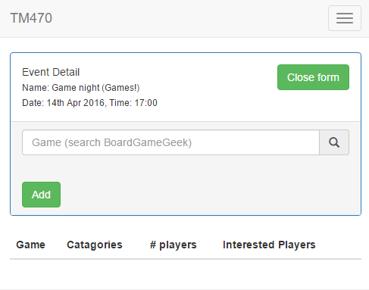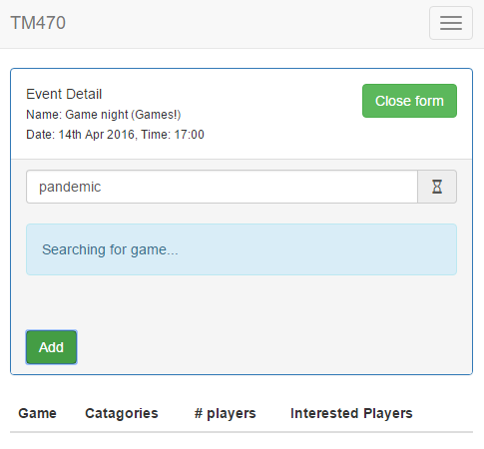
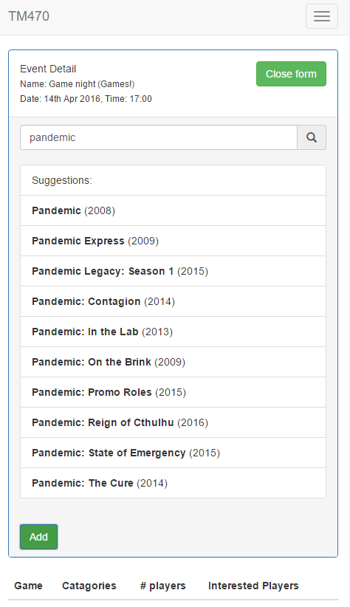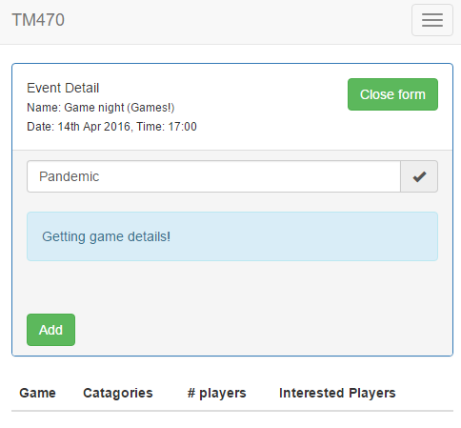

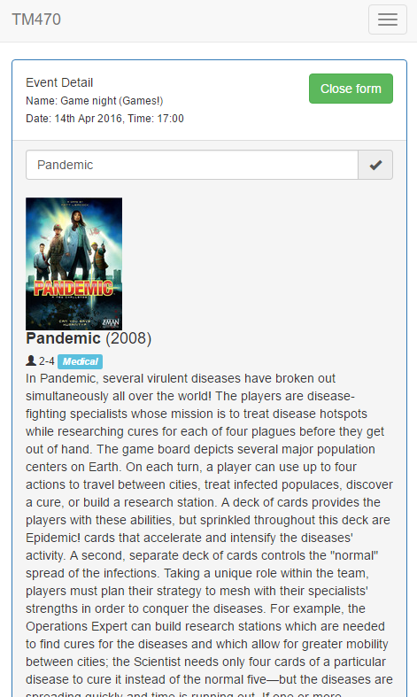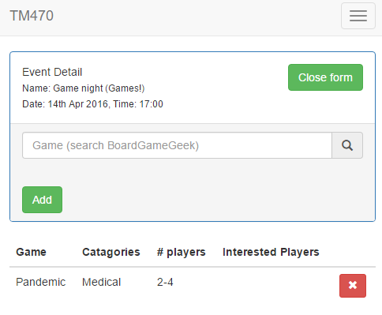

Appendix G
Images of incorrectly sanitised text
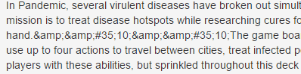
Figure 4 - Unexpected characters in text output
Figure 5 - Original text at source website
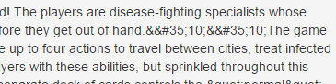
Figure 6 - client-side sanitisation – some characters have been displayed as HTML
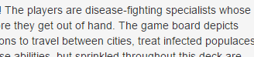
Figure 7 - server-side sanitisation turned off – all characters now displayed as HTML
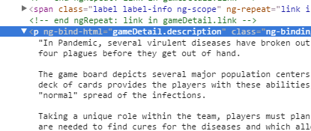
Figure 8 - generated code shows “newline” characters creating new lines

Appendix H
Project log since submission of previous TMA

Development and TMA
Created: | 10/04/2016 21:07
5 hours.
Continued fleshing out the prototype. Working on the front- and back-end at the same time has proven much more productive (after resolving most of the authentication issues). Working with external APIs also has meant that adding a feature involves a lot more debugging, testing and documentation but I am gaining a lot of experience.
The TMA is going slowly again as I struggle to know what to write. I should look back at my previous TMA reflection and try to think about how I got past this before.

Fleshing out prototype
Created: | 07/04/2016 01:05
4 hours.
Decided to quickly add in the front-end and business logic for the major aspects of the prototype: Events and Matches. This was successful and made me realise that I should have diversified my development a bit earlier to not get stuck and demoralised. I also added in the live search for games with the Board Game Geek API.

TMA prep
Created: | 05/04/2016 22:09
3 hours.
Taken some time to go over the previous TMA and its feedback, as well as the requirements for TMA 02, gathering evidence and materials, such as photos from the group and initial user comments.

More fixes
Created: | 01/04/2016 21:17
3 hours.
Spent more time trying to fix authorisation but I think that it is all working now, along with user details updating correctly. Started to move both sign up and login to pages with AJAX calls, so that the API is more API-like, in sending http responses rather than redirects.

Fixing authorisation and logging
Created: | 31/03/2016 21:13
5 hours.
Spent the afternoon including some more logging of server requests, so that I can better see what is happening when. Managed to cover most areas except the Passport middleware, which doesn't have access to the request. Will probably move towards a fuller featured logging tool in the future.
Spent adding hashing and salting to the password storage to improve security, and finding more and more problems with the authorisation code. Took some time away from the code to read more about security.

Catching up, development and debugging
Created: | 31/03/2016 02:06
9 hours.
After some time away from studying, it took a while to get back into development and remember exactly where I was - I'll need to work out a method of keeping track of exactly what has been done. I should really leave fuller git commit messages and perhaps I should add code comments to all additions and changes (git shows code differences, so maybe I can use that to make notes before committing).
I began work on the front-end as a change of 'scenery' but quickly came up against the shortcuts I took working on the back-end, like page rendering and http redirects instead of http response messages and status codes. Implementing the front-end has also created a lot of work in routing and structure - today it definitely feels like I have made this project too complicated and I wonder if I will be able to complete the later features. In particular, I am still doing so much reading and learning, that actual progress is slow and made worse with bugs and unclear documentation.

Learning
Created: | 05/03/2016 18:30
4 hours.
Spent some time today learning more about Node modules, Passport authentication and Express routing. A lot more confident in my understanding of the server platform.

More Exploration
Created: | 04/03/2016 22:36
3 hours.
A little reading on accessibility and ARIA tags. Installed Colour Contrast Analyser for later use to determine suitable colours.
Started investigating and experimenting with Passport user authentication. Was a lot more complicated than I thought. May need to reconsider my structure slightly.

Exploration
Created: | 01/03/2016 17:42
1 hour.
I installed the BoardGameGeek (BGG) API node.js package to test it out - tested it with pulling user profile info for my username. It seems to work nicely.
Have also installed Passport and passport-local for basic user authentication and Angular-socket-io for Socket to work nicely with Angular. Passport gives the ability to allow other types of login, such as twitter & facebook.
Installed Angular Batarang Chrome extension to allow for debugging of Angular apps.
TODO: need to examine the Angular-Express seed project for best practice in structuring the app.

